Title Page
Introduction (SDL):
- With any current software development or maintaining of software, one will find a Software Development Life Cycle (SDLC) process.
- Why I chose the two to compare and contrast.
- Being in the job market, experience with the Agile methodology is one of the most sought-after qualities that companies are looking for in a candidate. Furthermore, since the Agile methodology was born from the Traditional methodology, it would be beneficial to gain a better understanding of both.
Overview of Traditional:
- Traditional software development methodologies include the Spiral model, V-Model and RUP. Methodologies like these “are based on a sequential series of steps like requirements definition, solution building, testing and deployment (Leau, Y. B., Loo, W. K., Tham, W. Y., & Tan, S. F. (2012).”
- One of the most common traditional methods is the waterfall method, which is a sequential, linear process “that consists of several discrete phases. No phase begins until the prior phase is complete, and each phase’s completion is terminal—waterfall management does not allow you to return to a previous phase. The only way to revisit a phase is to start over at phase one (What the Waterfall Project Management Methodology Can (and Can't) Do for You, 2018)”.
- (https://d2slcw3kip6qmk.cloudfront.net/marketing/blog/2017Q3/Waterfall/WaterfallDiagram.png)
- The waterfall method consists of the following processes that are done in sequential order:
  - Requirements gathering and documentation
  - System design
  - Implementation
  - Testing
  - Delivery & Deployment
  - Maintenance (What the Waterfall Project Management Methodology Can (and Can't) Do for You, 2018) (Make a table explanation!!!)

Overview of Agile:
- Agile software development methodologies which include the Scrum method, Feature-driven development, and Extreme programming (XP), are based on the idea of progressive and iterative development. Thusly, the phases within the development life cycle are continuously reevaluated. This process regularly improves software by collecting customer feedback to gauge solutions and new features. These methodologies are based on the iterative stages that involve:
  - Project initiation
  - Sprint planning
  - Demos (Morelos, 2019)(Make a table exp!!!)
- One of the most common agile methodologies is the Scrum Methodology which “is an agile project management methodology or framework used primarily for software development projects with the goal of delivering new software capability every 2-4 weeks (What Is Scrum Methodology? 2020).”
- (What is Scrum?)
How they compare:
- dfgd
How they contrast:
- dfgd
Traditional Advantages, Disadvantages, Applications:
- dfgd
Agile Advantages, Disadvantages, Applications:
- dfgd
Conclusion:
- dfg

Images:
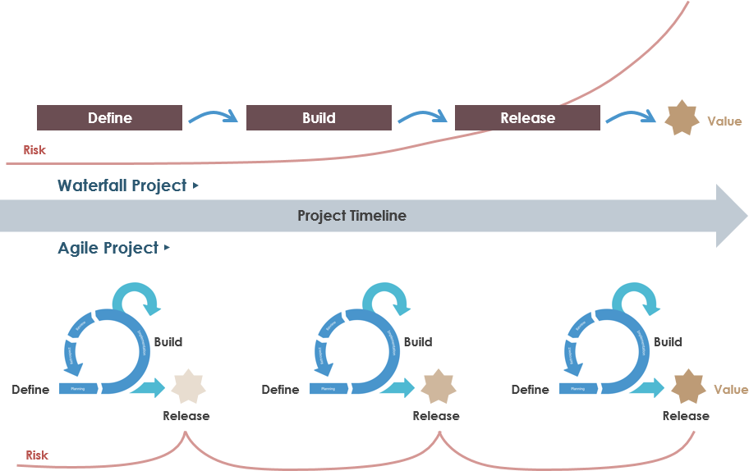
https://www.visual-paradigm.com/servlet/editor-content/scrum/what-is-agile-software.../sites/7/2018/12/agile-vs-waterfall-risk.png

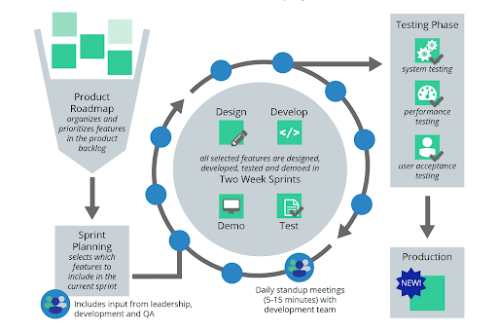 https://lh3.googleusercontent.com/proxy/NOEKd3llKp2nS0UDX44WC-lOllS_Zhw0-IaVHZwoOXfvtPOArRATRn1C4X65udr5uijpW1z2OuEY_ImP95zOpxxYKF9BF-wk4BXl7MsifDbyptkQKiX3kyOMT1gakQhj5Gwz_16U
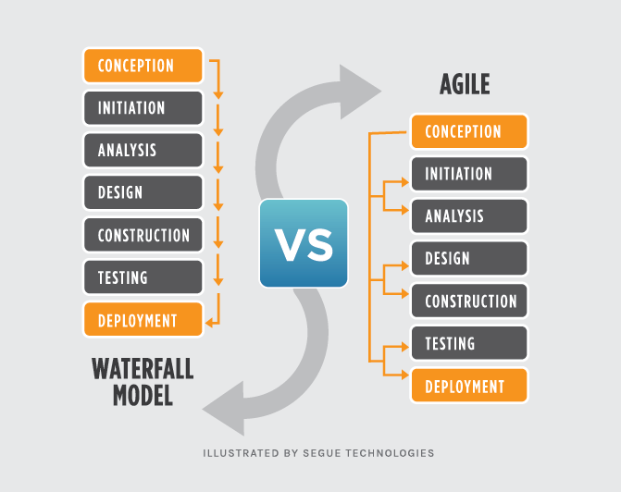
https://www.seguetech.com/wp-content/uploads/2013/07/segue-blog-waterfall-vs-agile-which-is-right-development-methodology-for-your-project.png

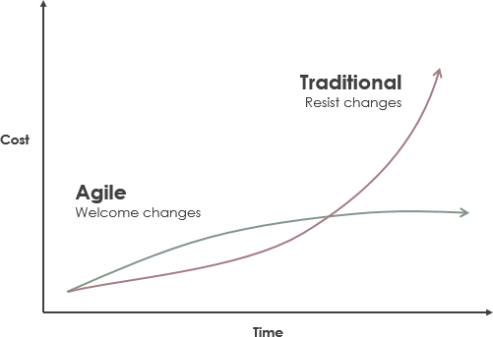 https://www.visual-paradigm.com/servlet/editor-content/scrum/classical-vs-agile-project-management/sites/7/2018/11/traditional-vs-agile-cost-of-change.png
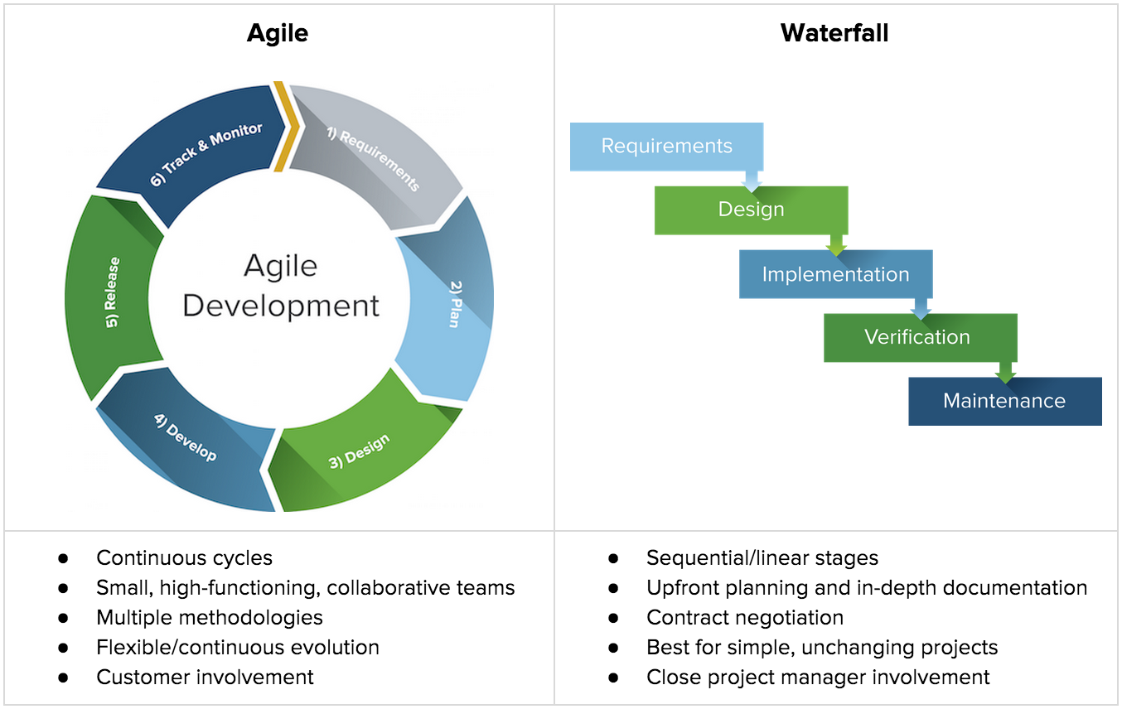
https://bajau.com/content/What-we-do/Consultancy/CI-CD/Waterfall-vs-Agile/vs.png

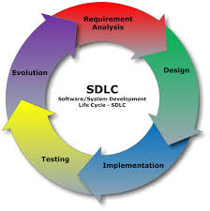
https://www.dataversity.net/how-you-should-approach-the-secure-development-lifecycle/
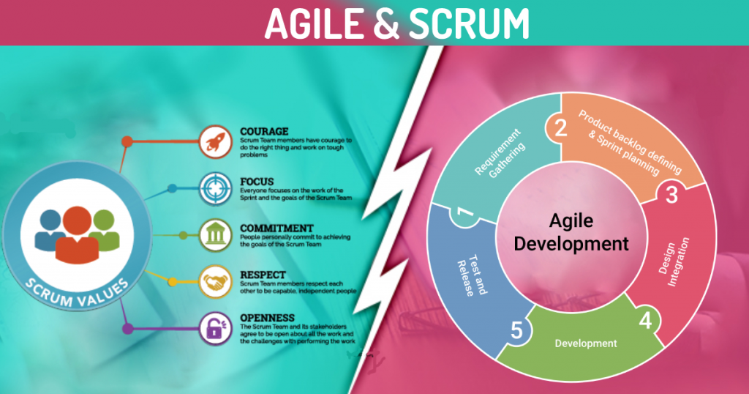
https://miro.medium.com/max/1024/0*w_vE9ohFTY3nATa2.png
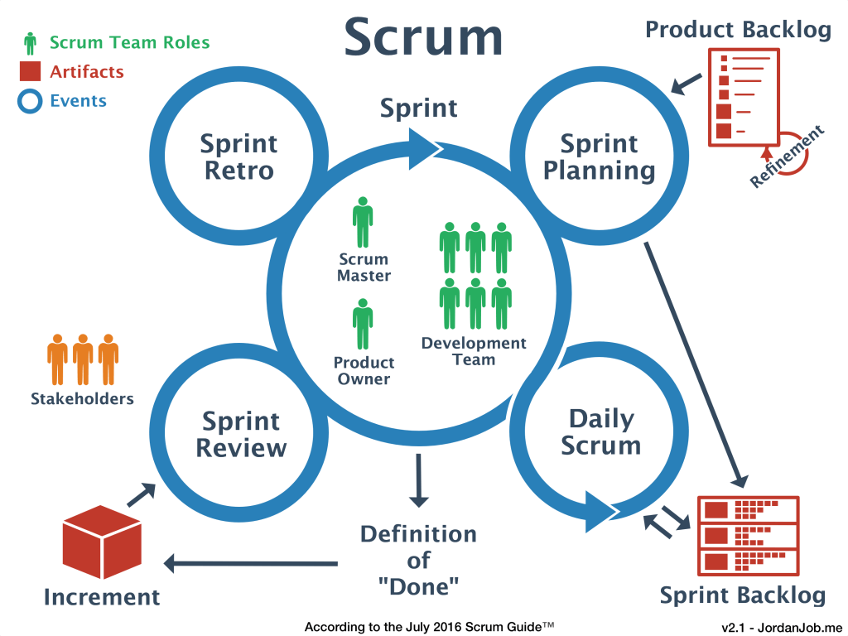
https://medium.com/@jw207427/how-scrum-help-turn-around-our-development-process-dac6ff7c700
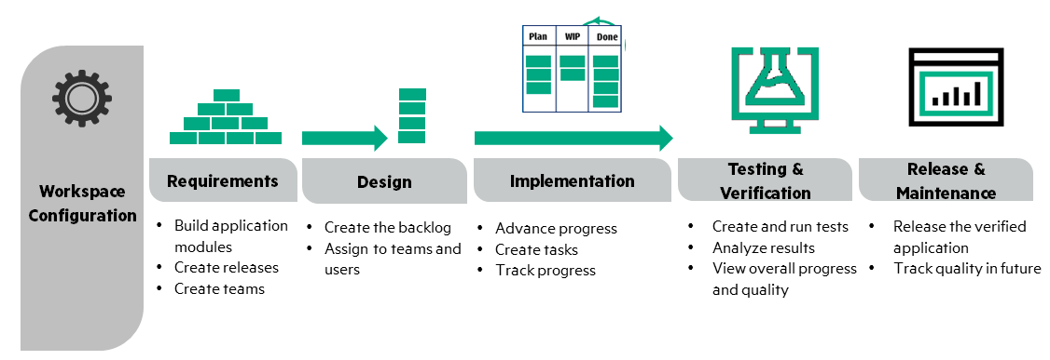
https://admhelp.microfocus.com/octane/en/CP7/Online/Content/Flows/images/SW_Development_Lifecycle.png
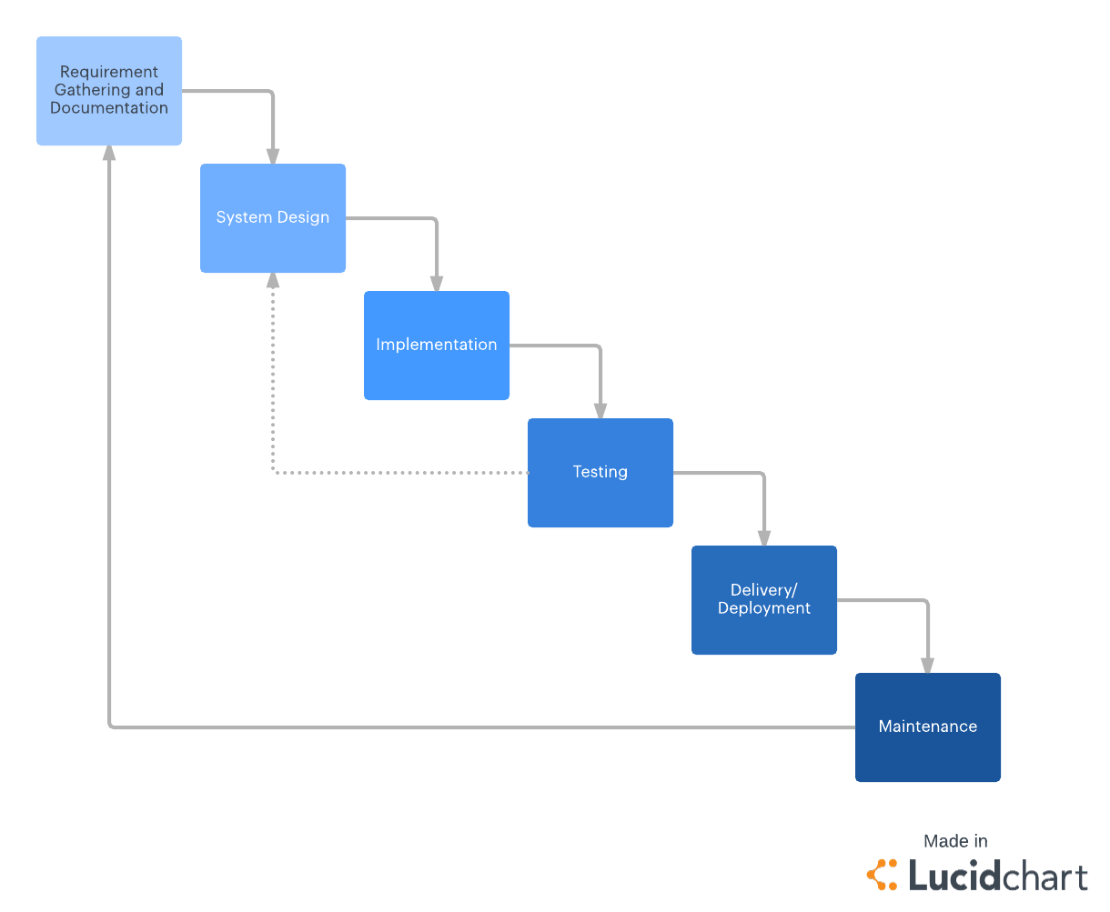
https://d2slcw3kip6qmk.cloudfront.net/marketing/blog/2017Q3/Waterfall/WaterfallDiagram.png

References:
Leau, Y. B., Loo, W. K., Tham, W. Y., & Tan, S. F. (2012). Software development life cycle AGILE vs traditional approaches. In International Conference on Information and Network Technology (Vol. 37, No. 1, pp. 162-167).
Morelos, D. (2019, August 07). Traditional vs. Agile Software Development Method: Which One is Right for Your Project? - DZone Agile. Retrieved June 22, 2020, from https://dzone.com/articles/traditional-vs-agile-software-development-method-w
What Is Scrum Methodology? (2020, February 16). Retrieved June 22, 2020, from https://resources.collab.net/agile-101/what-is-scrum
What the Waterfall Project Management Methodology Can (and Can't) Do for You. (2018, September 05). Retrieved June 22, 2020, from https://www.lucidchart.com/blog/waterfall-project-management-methodology
What is Scrum? (n.d.). Retrieved June 22, 2020, from https://www.scrum.org/resources/what-is-scrum

